System Analysis and Design Project Report

Faculty of Computers and Information

Team Project :
- 93
- 93
- 93
- 93
- 93
- 93

System Design: Bookstore

1. Introduction
This project entails the establishment of a specialized bookstore dedicated exclusively to system design literature. Unlike conventional bookstores, this initiative aims to create a curated environment tailored specifically for professionals, students, and enthusiasts engaged in the complex fields of system architecture and design methodologies. The bookstore will serve as a comprehensive resource center, offering both traditional print volumes and digital formats, alongside complementary educational materials such as practice compilations and professional development resources.
The purpose of this document is to provide a strategic blueprint for the planning and implementation of this specialized bookstore. It outlines a detailed yet adaptable approach that addresses all critical phases-from initial conceptualization and market analysis to operational and technical considerations. By following this structured methodology, the project is positioned to meet the growing demand for consolidated, authoritative system design knowledge and to foster a vibrant community of practitioners.
The current marketplace for technical literature presents notable challenges, including fragmented availability of system design resources and inadequate categorization that impedes efficient discovery. This venture addresses these gaps by offering a focused collection organized through a sophisticated categorization framework reflecting the multidisciplinary nature of system design. Furthermore, it will integrate advanced recommendation systems tailored to users’ career trajectories and expertise levels, thereby enhancing the learning experience.
In addition to serving as a retail outlet, the bookstore will provide flexible physical spaces conducive to professional development activities, including consultations, presentations, and community gatherings. A tiered membership structure will grant privileged access to premium content, early releases, and exclusive interactions with domain experts. An advisory council composed of industry authorities will guide collection development and educational programming to ensure ongoing relevance and excellence.
This initiative not only aims to generate substantial revenue through diversified channels but also to establish a definitive authority in the system design educational marketplace. By fostering a collaborative professional community and leveraging proprietary data on emerging trends, the bookstore will create significant long-term value and competitive advantage.

Part 1: PLANNING

1.1 Introduction to the Problem Domain
The current technical literature marketplace presents significant challenges for professionals seeking specialized knowledge. Conventional bookstores typically disperse valuable system design texts across disparate sections, creating substantial discovery barriers for those requiring comprehensive resources.
As industry complexity increases, system design knowledge has become increasingly vital in professional advancement, particularly for leadership positions and assessment processes at prestigious organizations. Practitioners require consolidated access to authoritative materials on architecture patterns, scalability considerations, and integrated design approaches—ideally centralized in a dedicated resource center.
Your establishment will address this unmet need by creating the first specialized marketplace dedicated exclusively to system design literature, offering traditional print volumes alongside digital formats and complementary educational resources such as practice compilations and preparation materials for professional advancement.
The discipline of system design encompasses numerous subdomains, each with its own corpus of essential texts and methodological approaches. Current retail models fail to recognize these nuanced distinctions, often categorizing materials using overly broad classification schemes that obscure rather than illuminate the relationships between interconnected topics. This fragmentation creates significant inefficiencies for practitioners attempting to build comprehensive knowledge foundations.
Moreover, the rapid evolution of design methodologies requires curated access to both foundational texts and emerging perspectives—a balance rarely achieved in general bookstores. Your specialized establishment will bridge this gap through thoughtful organization, expert curation, and community-centered knowledge sharing that recognizes the interconnected nature of system design disciplines.

1.2 System Request
Project Sponsorship: Investment Consortium Business Necessity: Establish a specialized literary center focused exclusively on system design publications
Core Business Requirements:
- Develop both physical establishment and digital commerce presence with seamless integration between environments
- Implement specialized categorization framework for technical publications that reflects the multidisciplinary nature of system design
- Create sophisticated recommendation mechanisms based on career trajectory and expertise levels with adaptive learning capabilities
- Design physical spaces conducive to professional development gatherings including flexible consultation areas and presentation facilities
- Implement tiered membership structure with privileged access to premium resources, early release publications, and exclusive author interactions
- Develop curated reading pathways tailored to specific professional development objectives
- Establish an advisory council of domain experts to guide collection development and educational programming
- Create collaborative spaces for practitioner knowledge exchange and mentorship opportunities
Business Value Proposition:
- Substantial projected initial-period revenue with strong growth potential through multiple complementary channels
- Anticipated consistent expansion throughout initial operational phase with increasing returns as community engagement deepens
- Diversified revenue streams through educational programming, subscription offerings, and specialized consultation services
- Establishment of definitive authority in system design educational resources with potential for intellectual property development
- Creation of robust professional community with significant network effects enhancing institutional value
- Development of proprietary datasets regarding emerging trends and methodological preferences with commercial applications
Special Considerations and Constraints:
- Initial collection acquisition requires substantial capital commitment with careful attention to breadth versus depth considerations
- Specialized categorization frameworks necessitate input from domain authorities across multiple disciplines
- Digital representation of technical diagrams presents unique display challenges requiring specialized viewing technologies
- Physical location selection requires balancing accessibility with operational viability and community-building potential
- Staff recruitment must prioritize both literary expertise and practical system design experience to maintain credibility
- Seasonal variations in educational interests require flexible inventory management approaches
- Copyright and digital rights management present complex challenges requiring specialized legal guidance

1.3 Feasibility Analysis
Following exhaustive research and multifaceted analysis, this project demonstrates feasibility across essential dimensions:
Technical Implementation Feasibility: The requisite infrastructure for both physical and digital presences relies on established methodologies. The primary technical challenges—developing intuitive categorization systems and personalized recommendation frameworks—can be addressed through existing approaches augmented by specialized domain expertise.
The implementation will benefit from modular design approaches, allowing for progressive enhancement as user behavior patterns emerge. Content management systems can be adapted from existing frameworks with customizations specific to technical literature. The recommendation engine can initially employ rule-based approaches before evolving toward more sophisticated machine learning implementations as usage data accumulates.
Integration between physical and digital inventories presents moderate complexity but can be managed through established middleware solutions with appropriate customization. The digital reading experience requires particular attention to technical diagram representation, potentially necessitating partnerships with specialized rendering technology providers to ensure optimal visualization across device types.
Schedule Implementation Feasibility: The proposed implementation timeline provides sufficient allocation for all essential phases:
- Initial planning and conceptual design, including stakeholder alignment and vision refinement
- Development of digital presence and inventory management systems with multiple testing iterations
- Physical space preparation and environmental design emphasizing both aesthetic and functional considerations
- Collection acquisition and systematic organization guided by domain specialists
- Comprehensive validation and controlled introduction phases with feedback incorporation mechanisms
- Phased rollout of community features and educational programming
- Staff recruitment and specialized training programs
The critical path runs through the development of the categorization system, as this foundational element influences numerous downstream components. Adequate time must be allocated for expert consultation and validation of the taxonomic approach. Similarly, the integration between physical and digital inventory systems represents a schedule risk requiring appropriate contingency allocations.
Operational Feasibility: Comprehensive market assessment indicates robust demand from target constituencies (design practitioners, architectural specialists, departmental leadership). Existing alternatives including general literary establishments and digital marketplaces lack the specialized focus and community dimensions this venture will provide.
Operational challenges primarily center around maintaining curatorial excellence as the collection expands. This necessitates ongoing relationships with subject matter experts and publishers specializing in relevant domains. The establishment must balance comprehensive coverage with selectivity to maintain its value proposition as a curated resource rather than merely a aggregator.
Community engagement represents both an opportunity and operational challenge, requiring dedicated staff resources to facilitate meaningful interactions and maintain programmatic relevance. Educational offerings must be developed with careful attention to practitioner needs, potentially through advisory committees comprising representative customers.

1.4 Economic Feasibility
Our exhaustive financial analysis reveals compelling economic potential:
Implementation Investments:
- Digital platform development representing substantial initial investment, including specialized search capabilities and recommendation systems
- Inventory management infrastructure requiring significant allocation, with particular emphasis on cross-referencing capabilities and metadata richness
- Physical space preparation and experiential design elements, balancing functional requirements with atmospheric considerations
- Initial collection acquisition representing primary capital commitment, requiring careful balancing of breadth and depth
- Market positioning and launch initiatives requiring appropriate resources across multiple channels
- Staff recruitment and specialized training programs to ensure consistent customer experience
- Advisory board development and community building initiatives requiring both financial and relational investments
- Customized furniture and fixtures designed specifically for technical material consultation
Anticipated Returns:
- First operational period projections indicating strong revenue generation through multiple complementary channels
- Subsequent operational periods showing substantial growth trajectories as community engagement deepens
- Strategic financial equilibrium achieved within early operational phase with accelerating returns as network effects manifest
- Long-term investment return metrics exceeding industry standards for specialty retail
- Secondary revenue streams developing from educational programming and professional services
- Tertiary opportunities through data analytics and potential publishing initiatives
- Sustained competitive advantage through community loyalty and specialized expertise
Additional Value Considerations:
- Establishment of preeminent position in specialized educational marketplace with significant brand equity development
- Acquisition of proprietary audience insights enabling future expansion into adjacent domains
- Foundation for diversification into complementary educational services and potential certification programs
- Development of intellectual property through curated pathways and methodological frameworks
- Creation of valuable professional network with potential for strategic partnerships
- Accumulation of specialized data regarding emerging methodological trends

1.5 Requirements Definition
Nonfunctional Requirements:
- Performance Parameters
  - Digital platform must maintain consistent responsiveness under varying conditions, including peak usage periods during professional development cycles
  - Inventory synchronization must occur with minimal latency between physical and digital systems to prevent customer disappointment
  - Search capabilities must deliver contextually relevant results with exceptional responsiveness, incorporating semantic understanding of technical relationships
  - System must accommodate periodic usage spikes corresponding to industry events and publication cycles
  - Batch processing operations must complete within maintenance windows without affecting customer experience
  - Content delivery networks must ensure consistent digital asset availability across geographical locations
- Security Provisions
  - Financial transactions must adhere to industry-leading protection standards with regular security assessment
  - Customer information must receive comprehensive protection measures including appropriate anonymization
  - Access privileges must implement granular controls based on organizational roles with regular audit procedures
  - Digital rights management must protect publisher interests while ensuring legitimate customer access
  - Authentication systems must balance security requirements with usability considerations
  - Data retention policies must comply with relevant regulations while supporting analytical needs
  - Intrusion detection systems must provide early warning of potential security incidents
- Usability Considerations
  - Navigation architecture must facilitate discovery through multiple taxonomic approaches reflecting diverse learning styles
  - Mobile experience must maintain functional parity with traditional interfaces while optimizing for device-specific interaction patterns
  - Technical illustrations must maintain integrity across varying display environments with appropriate zoom capabilities
  - Interface design must accommodate varying technical proficiency levels without compromising depth
  - Accessibility features must ensure content availability to users with diverse abilities
  - Information architecture must support both directed search and serendipitous discovery
  - User interface elements must employ consistent patterns to reduce cognitive load
- Reliability Standards
  - Digital platform must maintain exceptional availability metrics with appropriate redundancy
  - Information preservation protocols must operate on regular schedules with validation procedures and disaster recovery capabilities
  - Continuity systems must activate seamlessly upon detection of primary system irregularities with minimal service interruption
  - Degradation pathways must ensure core functionality remains available during partial system failures
  - Maintenance procedures must minimize customer impact through appropriate scheduling
  - Monitoring systems must provide early warning of potential capacity or performance issues
  - Recovery time objectives must be established and regularly tested for all critical systems
Functional Requirements:
- Inventory Stewardship
  - System must maintain distinct tracking for physical and digital assets with appropriate synchronization mechanisms
  - System must support sophisticated categorization with extensive cross-referencing capabilities reflecting the multidisciplinary nature of system design
  - System must incorporate automated supply chain management with appropriate triggers based on customizable thresholds
  - System must accommodate publisher-specific procurement workflows and timeframes with flexible integration options
  - System must track edition changes and maintain relationships between successive versions
  - System must support bundling of related materials across formats and publishers
  - System must facilitate special order capabilities for rare or specialized texts
  - System must support reservation and notification workflows for popular or limited availability items
- Customer Experience Architecture
  - Patrons must have access to personalized profile creation with professional context and learning objectives
  - System must deliver contextual recommendations based on developmental trajectory and declared interests
  - Patrons must enjoy consistent access to digital acquisitions across various environments with synchronized progress tracking
  - System must support acquisition planning with notification capabilities for relevant publications and subject areas
  - System must facilitate creation and sharing of curated collections among community members
  - System must provide personalized learning pathways based on career objectives and current knowledge
  - System must enable annotation and note-taking capabilities integrated with personal knowledge management
  - System must support community-generated reviews with credibility indicators and filtering options
- Community Engagement Framework
  - System must facilitate professional gathering registration with capacity optimization and waiting list management
  - System must enable structured discourse organized by specialization domains with appropriate moderation tools
  - System must accommodate expert engagement sessions and professional development offerings including resource management
  - System must incorporate peer assessment with expertise validation indicators based on transparent criteria
  - System must support formation of special interest groups around specific methodologies or domains
  - System must facilitate mentorship connections between practitioners at different experience levels
  - System must enable collaborative problem-solving through appropriate discussion frameworks
  - System must support recognition mechanisms for valuable community contributions
- Analytical Capabilities
  - System must capture comprehensive patron interaction patterns while respecting privacy considerations
  - System must generate insights regarding subject matter performance and emerging interests across demographic segments
  - System must provide visibility into educational engagement effectiveness with outcome correlation
  - System must identify correlations between collection performance and industry dynamics to inform acquisition strategies
  - System must support cohort analysis to identify patterns in learning progression
  - System must enable comparison between projected and actual performance across multiple dimensions
  - System must facilitate hypothesis testing regarding community preferences and behaviors
  - System must generate actionable recommendations for operational improvements and strategic initiatives

1.6 Interacting Parties
The ecosystem will engage with diverse constituencies and external entities:
Primary Constituencies:
- Design Practitioners (various experience levels) seeking to expand methodological knowledge
- Architectural Specialists requiring deep domain expertise and cross-disciplinary perspectives
- Departmental Leadership researching organizational transformation approaches
- Academic Participants connecting theoretical foundations with practical applications
- Talent Acquisition Specialists seeking to understand competency development pathways
- Organizational Development Departments building internal capability frameworks
- Independent Consultants requiring comprehensive resources for client engagements
- Career Transitioners moving into specialized design disciplines
- Continuing Education Participants fulfilling professional development requirements
- Research Teams exploring emerging methodological approaches
Operational Personnel:
- Establishment Associates (collection management and patron assistance) with specialized domain knowledge
- Content Curation Specialists (organization and recommendations) maintaining taxonomic integrity
- Professional Development Coordinators (educational programming) aligning offerings with community needs
- Market Engagement Team (promotional initiatives and communications) translating complex topics for varied audiences
- Subject Matter Advisors ensuring content relevance and methodological currency
- Technical Platform Specialists maintaining digital systems and integration points
- Community Facilitators fostering meaningful interactions and knowledge exchange
- Executive Leadership balancing mission fulfillment with operational sustainability
External Ecosystems:
- Publishing Houses and Distribution Networks providing core inventory and market intelligence
- Financial Transaction Processors enabling secure commercial operations
- Fulfillment Service Providers ensuring timely delivery of physical materials
- Communication Management Platforms supporting community engagement initiatives
- Professional Association Partners providing credibility and audience access
- Institutional Relationship Management Systems facilitating organizational purchases
- Educational Institutions seeking specialized resources for curriculum development
- Standards Organizations documenting methodological best practices
- Research Institutions exploring emerging approaches and theoretical foundations
- Technology Providers supporting specialized visualization and interaction needs
Information Exchange Patterns:
- Collection updates from publishers to establishment systems with rich metadata transmission
- Patron preferences informing recommendation mechanisms through explicit and implicit signals
- Historical engagement informing promotional strategies with appropriate personalization
- Educational programming coordinating with notification systems based on expressed interests
- Taxonomic refinements propagating across all platforms maintaining conceptual integrity
- Community insights informing collection development priorities
- Usage patterns guiding physical space optimization initiatives
- Subject matter trends informing special event programming
- Feedback mechanisms enhancing service quality and relevance
Each interaction necessitates purpose-built interface designs, information exchange protocols, and performance expectations to ensure seamless operational integrity and exceptional patron experiences throughout all engagement touchpoints.
The establishment's success will ultimately depend on the harmonious integration of these components, creating an environment where knowledge discovery, professional growth, and community engagement converge to create unprecedented value for system design practitioners.

Entity Details for System Design Bookstore

1. Customer
- Attributes:
  - customerId: String (Primary key, unique identifier for each customer)
  - name: String (Full name of the customer)
  - email: String (Contact email address, likely used for notifications and account access)
- Implicit Attributes (not shown but likely needed):
  - password/authentication details
  - address information for shipping
  - account creation date
  - preferences/profile information
- Relationships:
  - Has exactly one ShoppingCart (1:1 relationship)
  - Places zero or more Orders (1:0..* relationship)
- Responsibilities:
  - Maintains personal profile
  - Browses publications
  - Manages shopping cart
  - Places and tracks orders

2. WebInterface
- Operations:
  - displayCollection(): Renders the available publications to customers, likely with filtering/sorting
  - processCheckout(): Handles the checkout flow when a customer is ready to purchase
- Implicit Operations (not shown but likely needed):
  - authenticateUser()
  - manageUserProfile()
  - searchPublications()
  - viewOrderHistory()
- Relationships:
  - Displays information from the InventorySystem
  - Manages the RecommendationEngine (1:1 relationship)
- Responsibilities:
  - Provides user interface for all customer interactions
  - Coordinates between backend systems
  - Handles display logic and user experience

3. Publication
- Attributes:
  - publicationId: String (Primary key, unique identifier for each publication)
  - title: String (Name of the book/publication)
  - price: double (Cost of the publication)
  - format: String (Specifically either "PHYSICAL" or "DIGITAL")
- Implicit Attributes (not shown but likely needed):
  - author(s)
  - publisher
  - publication date
  - ISBN
  - description
  - page count
  - categories/tags
  - availability status
- Relationships:
  - Managed by InventorySystem (0..*:1 relationship)
  - Recommended by RecommendationEngine
  - Contained in ShoppingCart(s)
  - Included in Order(s) as line items
- Responsibilities:
  - Encapsulates all publication data
  - Provides information for display, pricing, and fulfillment

4. InventorySystem
- Operations:
  - getAvailableTitles(): List<Publication> - Returns publications that are currently in stock
  - updateInventory(publicationId: String) - Updates stock levels, likely after purchases or restocking
- Implicit Operations (not shown but likely needed):
  - addNewPublication()
  - removePublication()
  - getPublicationDetails()
  - checkAvailability()
  - generateInventoryReports()
- Relationships:
  - Manages many Publications (1:0..* relationship)
- Responsibilities:
  - Tracks all publications in the system
  - Maintains stock levels for physical publications
  - Handles inventory reports and alerts
  - Manages publication metadata and availability

5. RecommendationEngine
- Operations:
  - getRecommendations(publicationId: String): List<Publication> - Suggests related publications
  - updateCustomerProfile(customerId: String) - Updates customer preferences for better recommendations
- Implicit Operations (not shown but likely needed):
  - analyzeCustomerBehavior()
  - identifyTrends()
  - computeSimilarityScores()
  - generatePersonalizedRecommendations()
- Relationships:
  - Recommends Publications to customers
  - Managed by WebInterface (1:1 relationship)
- Responsibilities:
  - Analyzes customer behavior and preferences
  - Generates personalized recommendations
  - Enhances discovery of relevant publications
  - Improves conversion rates through targeted suggestions

6. ShoppingCart
- Operations:
  - addItem(publication: Publication) - Adds a publication to the cart
  - removeItem(publicationId: String) - Removes a specific publication from the cart
  - getTotal(): double - Calculates the current cart total
- Implicit Operations (not shown but likely needed):
  - clearCart()
  - updateItemQuantity()
  - saveForLater()
  - applyDiscountCode()
  - checkoutCart()
- Relationships:
  - Belongs to exactly one Customer (1:1 relationship)
  - Contains multiple Publications
- Responsibilities:
  - Temporarily stores selected publications
  - Manages the shopping session
  - Calculates totals and applies any discounts
  - Prepares the order for checkout

7. Order
- Attributes:
  - orderId: String (Primary key, unique identifier for each order)
  - customer: Customer (Reference to the customer who placed the order)
  - items: List<Publication> (Collection of publications purchased)
  - status: String (Current state of the order: e.g., "Processing", "Shipped", "Delivered")
- Implicit Attributes (not shown but likely needed):
  - orderDate
  - shippingAddress
  - billingAddress
  - estimatedDeliveryDate
  - actualDeliveryDate
  - orderNotes
- Relationships:
  - Placed by one Customer (0..*:1 relationship)
  - Processed by FulfillmentSystem
  - Has exactly one PaymentDetails (1:1 relationship)
- Responsibilities:
  - Records all details of a purchase transaction
  - Tracks order status through fulfillment process
  - Links customer, items, and payment information
  - Provides history for customer service and reporting

8. FulfillmentSystem
- Operations:
  - createFulfillmentOrder(order: Order) - Initiates the fulfillment process for an order
  - shipItem(orderId: String) - Processes shipping for a specific order
- Implicit Operations (not shown but likely needed):
  - trackShipment()
  - generateShippingLabels()
  - manageDigitalDelivery()
  - processReturns()
  - updateOrderStatus()
- Relationships:
  - Processes Orders after payment
- Responsibilities:
  - Handles the logistics of order delivery
  - Coordinates physical shipping for physical books
  - Manages digital delivery for digital publications
  - Updates order status throughout fulfillment
  - Handles returns and exchanges

9. PaymentDetails
- Attributes:
  - amount: double (Total payment amount)
  - paymentMethod: String (Method used: e.g., "Credit Card", "PayPal", "Store Credit")
- Implicit Attributes (not shown but likely needed):
  - transactionId
  - paymentDate
  - cardType (if applicable)
  - lastFourDigits (for saved payment methods)
  - billingAddress
  - paymentStatus
- Relationships:
  - Belongs to exactly one Order (has relationship)
- Responsibilities:
  - Stores payment information securely
  - Records transaction details
  - Supports financial reporting and reconciliation
  - Provides payment verification
This comprehensive breakdown includes all explicit attributes and operations from the class diagram, plus implicit elements that would likely be present in a complete implementation. Each entity's responsibilities and relationships are described in detail to provide a thorough understanding of the system design.

1. Behavioural Diagrams

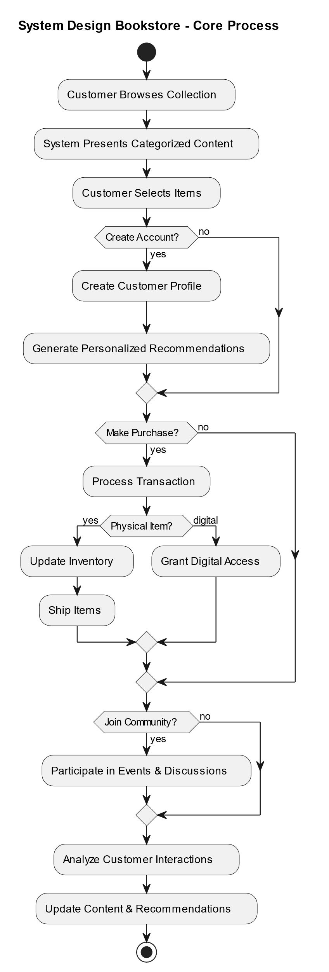
● Activity Diagram

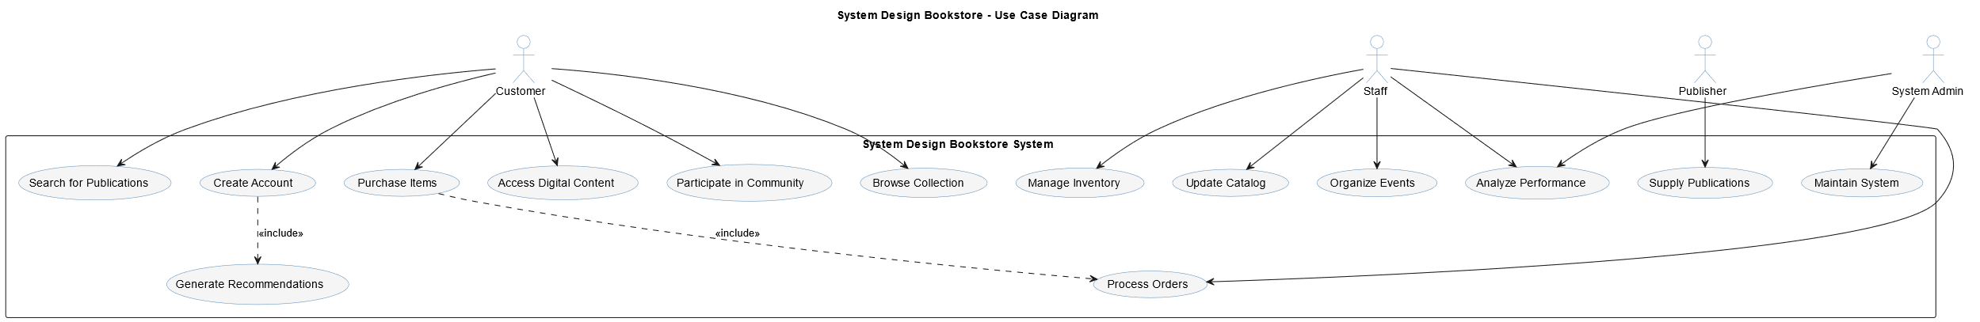
● Use-Case Diagram

● Sequence Diagram
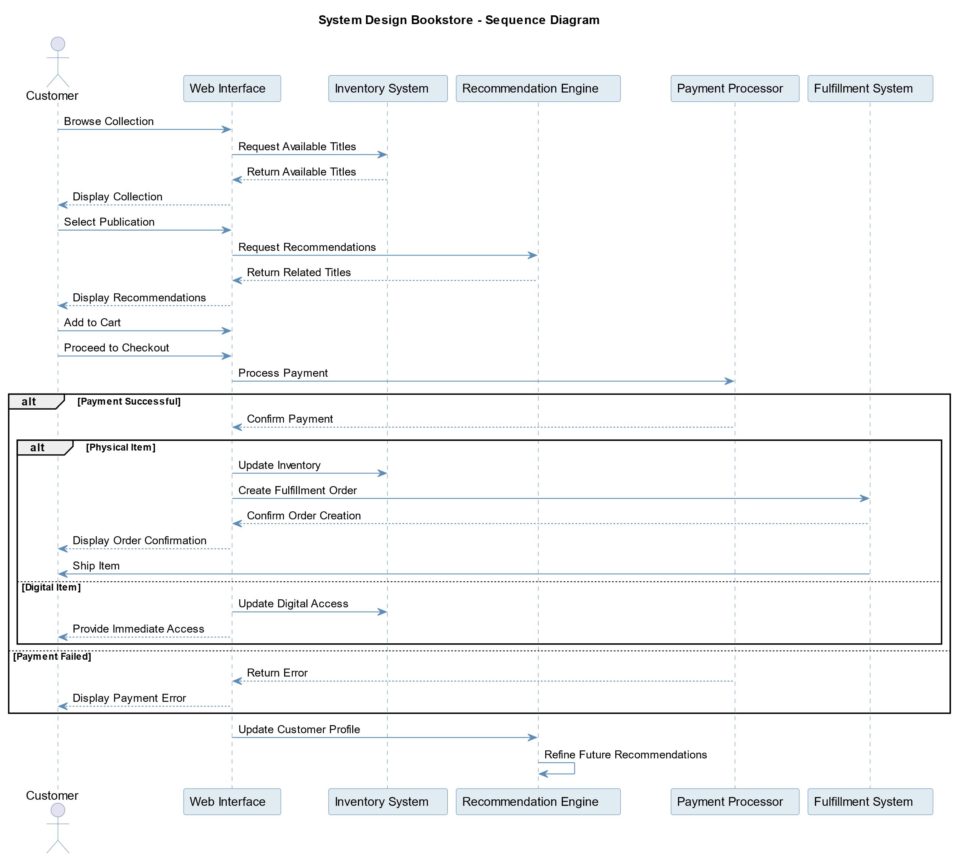

● Communication (Collaboration) Diagram

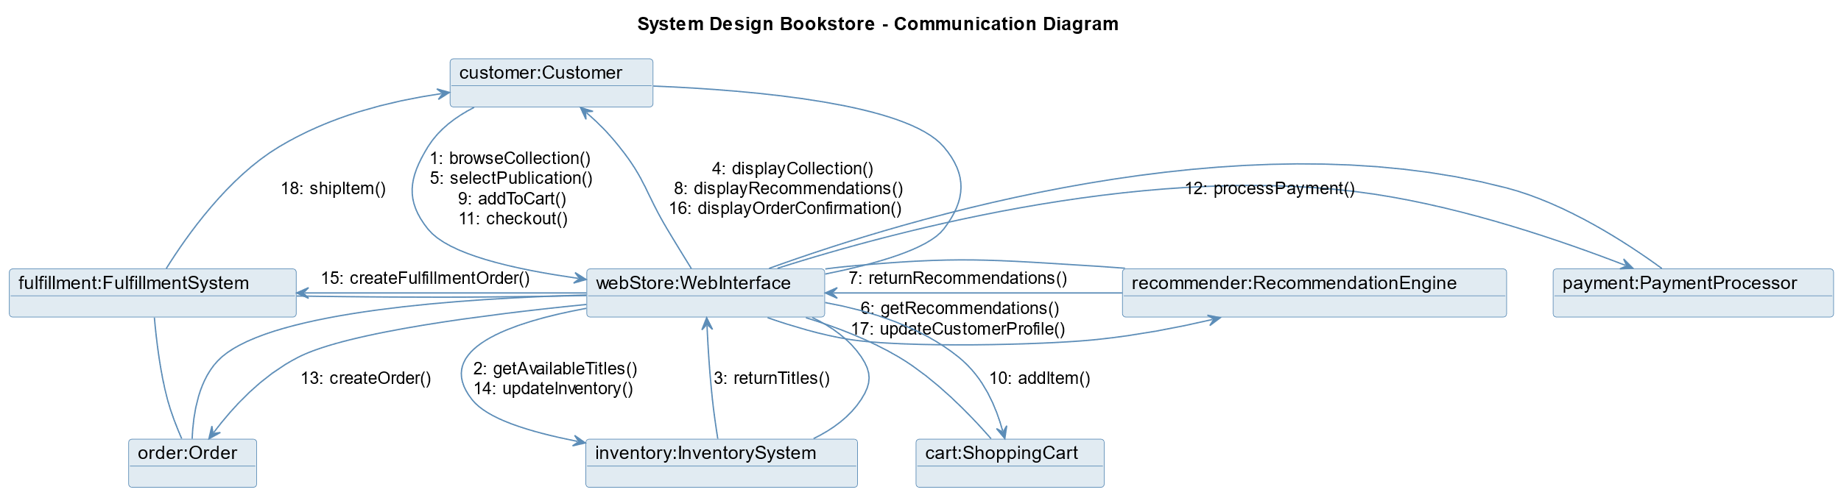

2. Structural Diagrams

● Class Diagram

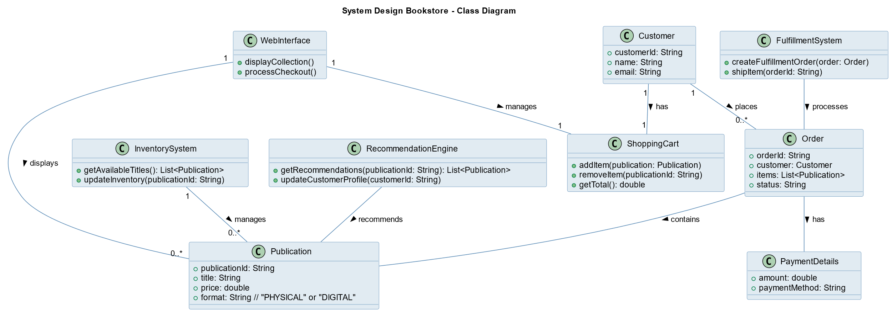

● Object Diagram

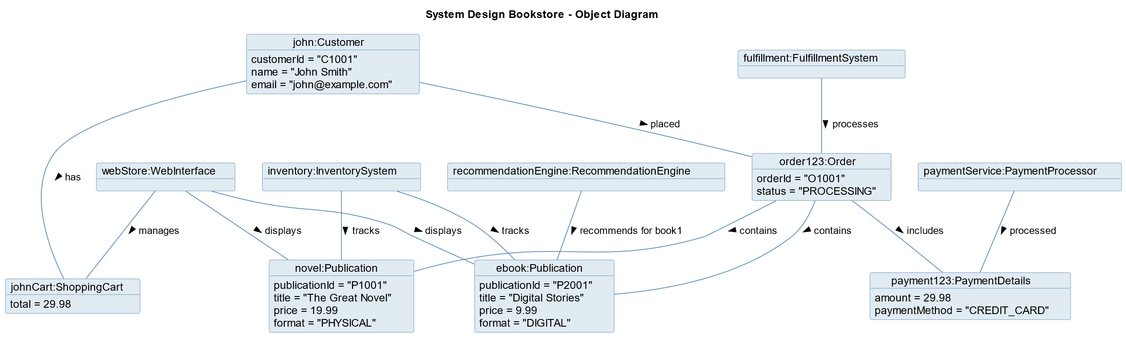

Data Flow Diagram
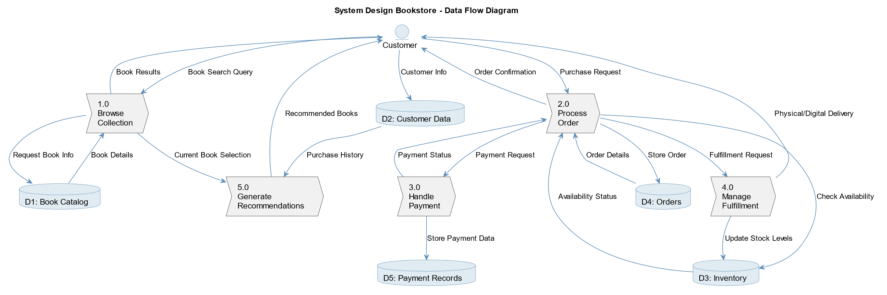

Interview
مقابله مع صاحب مكتبه حور العين
المقابل : أ.محمد احمد
المتحدث معه : الطالب عبدالرحمن وائل واعضاء الفريق
يوم الجمعه الموافق : 2/5/2025

س1: نظام استعارة الكتب دلوقتي ماشي إزاي؟
ج1: حاليًا لما حد ييجي يستعير كتاب، بنكتب اسمه واسم الكتاب وتاريخ الاستعارة في دفتر. ولما يرجعه ، بنشطب اسمه. كله ورقي ومفيش كمبيوتر خالص.

س2: إزاي بتعرف الكتب المتاحة دلوقتي للاستعارة؟
ج2: إحنا بنحسبها يدوي. لو كتاب اتاخد، بنخصمه من العدد اللي عندنا في الدفتر. بس ساعات بننسى أو نكتب غلط.

س3: إيه البيانات اللي بتاخدها من الشخص اللي بيستعير؟
ج3: بنكتب اسمه، ورقم تليفونه بس. مفيش بيانات تانية بناخدها.

س4: هل في مدة محددة لازم يرجّع فيها الكتاب؟
ج4: أيوه، عادة بنخلي مدة الاستعارة أسبوع. ولو اتأخر، بنحاول نفتكر نكلمه أو نتابعه، بس مش دايمًا بنلحق.

س5: بتتابع إزاي الناس اللي اتأخرت؟
ج5: بصراحة مفيش طريقة محددة. بنرجع نشوف الدفتر ونقعد ندور مين اتأخر، وساعات بننسى ناس خالص.

س6: إزاي بتسجل الكتب الجديدة اللي بتدخل المكتبة؟
ج6: لما نشتري كتب جديدة، بنكتب اسم كل كتاب وعدد النسخ اللي جت في الدفتر. مفيش تصنيف ولا أرقام أكواد.

س7: هل بتقسموا الكتب حسب نوعها؟
ج7: آه، بس بشكل بسيط. مثلًا: ركن للقصص، ركن للكتب الدينية، وركن للمدرسية. لكن مفيش تنظيم دقيق أو رقم لكل كتاب.

س8: إيه أكتر مشكلة بتقابلك في النظام الحالي؟
ج8: أكبر مشكلة إننا بنضيع البيانات بسهولة. لو الدفتر ضاع أو اتقطع، مفيش نسخة تانية. وكمان صعب نتابع كل الناس اللي عندهم كتب.

س9: هل بتحب يكون في نظام إلكتروني يساعدك؟

ج9: طبعًا. لو في حاجة بسيطة أقدر أسجل فيها الكتب والأسماء وتقولّي مين اتأخر، هتوفر عليا وقت ومجهود.

س10: تحب النظام يبعت رسائل أو تنبيهات لو حد اتأخر؟

ج10: أيوه، دي حاجة مفيدة جدًا. لو بعت رسالة على الموبايل أو حتى طلعلي في النظام إنه اتأخر، يبقى تمام.

س11: تحب الناس يعرفوا الكتب اللي موجودة في المكتبة؟
ج11: آه، لو في طريقة يقدروا يشوفوا من الموبايل أو يسألوني وأنا أشوف في النظام بسرعة، يبقى ممتاز.

س12: تحب يبقى فيه بحث عن الكتب بالاسم أو النوع؟
ج12: أكيد، بدل ما أقعد أدور في الدفتر أو على الرفوف.

س13: تحب النظام يحسب عدد النسخ المتاحة من كل كتاب؟
ج13: أيوه، دي هتسهل عليا جدًا، خصوصًا لما الناس تسألني عندك كام نسخة متوفرة.

س14: تحب تشوف تقارير زي مين بيستعير كتير أو الكتب المشهورة؟
ج14: آه، هتفيدني أعرف أكتر الكتب اللي الناس بتحبها، ومين أكتر ناس ملتزمين أو لا.

س15: تحب النظام يشتغل على كمبيوتر، ولا تحب يكون في تطبيق كمان؟
ج15: مبدأيًا كمبيوتر كفاية، بس لو في تطبيق بسيط للموبايل بعدين، مش هقول لأ.

Interview Notes
الملاحظات التي تم استناتجها من مقابله صاحب المكتبه:

1.المكتبة شغالة من زمان بنظام ورقي يدوي (دفاتر).

2.تسجيل الكتب والمستعيرين بيتم يدويًا (اسم، رقم تليفون، اسم الكتاب، التاريخ).

3.مفيش تصنيف دقيق للكتب ولا أكواد أو تنظيم إلكتروني.

4.مدة الاستعارة أسبوع واحد، وفي حالة التأخير المتابعة بتكون عشوائية أو غير منتظمة.

5.فقدان أو تلف الدفتر ممكن يسبب فقد بيانات مهمة.

6.عدد الزوار والمستعيرين كبير نسبيًا شهريًا (40-50 شخص).

7.مفيش نظام لحصر النسخ المتاحة أو معرفة الكتب الموجودة بسهولة.

8.لا يوجد تنبيهات تلقائية عند التأخير أو عند اقتراب موعد الإرجاع.

9.صاحب المكتبة مهتم بالبساطة، ويفضل نظام يكون باللغة العربية.

10.يفضل إمكانية البحث السريع عن الكتب أو المستعيرين.

11.مهتم بوجود تقارير بسيطة (أكتر الكتب استعارة، مين بيستعير كتير).

12.يرى أن نظام الكمبيوتر كفاية كبداية، لكن تطبيق موبايل هيكون ميزة إضافية مستقبلًا.

Conclusion
The development of an online bookstore management system addresses critical inefficiencies found in traditional bookstore operations by automating inventory control, sales tracking, and user management. Through the adoption of agile methodology, the project ensures iterative progress and adaptability to evolving requirements, resulting in a robust and user-friendly platform tailored to both administrators and customers. The system’s comprehensive features, including product catalogues, search functionalities, and secure transaction processes, enhance the overall user experience and operational efficiency. By streamlining bookstore management, this project not only improves accuracy and reduces manual errors but also supports scalability for future growth and integration of advanced functionalities. Ultimately, the system establishes a practical solution that meets the demands of modern online book retailing while fostering improved customer engagement and business performance.
The establishment of a specialized literary center dedicated to system design represents a significant opportunity to address an unmet market need while creating substantial value for multiple constituencies. Through careful planning and thoughtful implementation, this venture can transcend traditional retail models to become an essential resource for practitioners seeking to advance their capabilities in this critical domain.
The interconnected nature of the proposed systems—spanning physical and digital environments, individual and community experiences, commercial and educational objectives—creates a resilient ecosystem capable of evolving alongside the discipline it serves. By maintaining unwavering focus on practitioner needs while embracing operational excellence, the establishment can achieve sustainable competitive advantage in an increasingly knowledge-driven landscape.
Critical success factors include:
- Curatorial Excellence - Maintaining authoritative collection development guided by domain expertise and practitioner needs
- Community Cultivation - Fostering meaningful interactions that transcend transactional relationships to create enduring value
- Experience Integration - Seamlessly connecting physical and digital touchpoints to create coherent patron journeys
- Adaptive Learning - Continuously refining operations based on emerging patterns and explicit feedback
- Strategic Partnerships - Cultivating relationships with publishers, educational institutions, and professional organizations
- Knowledge Architecture - Developing sophisticated organizational systems that illuminate rather than obscure conceptual relationships
- Service Personalization - Recognizing the unique developmental trajectories of individual practitioners
- Operational Discipline - Maintaining sustainable business practices while pursuing mission fulfillment
The implementation plan outlined in this document provides a comprehensive foundation upon which to build this visionary establishment. Through disciplined execution tempered by continuous learning, the specialized bookstore can become not merely a commercial venture but an essential institution advancing the practice of system design across industries.

References

- Online Book Store System, UTPedia. Available at: http://utpedia.utp.edu.my/id/eprint/24035/1/Online%20Book%20Store%20System.pdf
- Design and Implementation of an Online Bookstore Management System, NairaProject. Available at: https://nairaproject.com/projects/4285.html
- Bookstore Management System Project Report, CIDCO College Nashik. Available at: https://www.cidcocollegenashik.ac.in/wp-content/uploads/2024/12/Ashwini-Niranjan-Wagh.pdf
- Design and Implementation of an Online Bookstore Management System: A Case Study of Kano Public Library in Nigeria, iProjectDownload. Available at: https://www.iprojectdownload.com/design-and-implementation-of-an-online-bookstore-management-system-a-case-study-of-kano-public-library-in-nigeria-kpl/
- Related References - Systems Oriented Design. Available at: https://systemsorienteddesign.net/systems-references/

Citations:
- http://utpedia.utp.edu.my/id/eprint/24035/1/Online%20Book%20Store%20System.pdf
- https://nairaproject.com/projects/4285.html
- https://systemsorienteddesign.net/systems-references/
- https://www.cidcocollegenashik.ac.in/wp-content/uploads/2024/12/Ashwini-Niranjan-Wagh.pdf
- https://www.iprojectdownload.com/design-and-implementation-of-an-online-bookstore-management-system-a-case-study-of-kano-public-library-in-nigeria-kpl/
- https://scholar.harvard.edu/files/waldo/files/ps-2006-6.pdf
- https://research.utwente.nl/files/14472302/Introduction_20to_20education_20design_20research.pdf
- https://www.academia.edu/28387929/DESIGN_AND_IMPLEMENTATION_OF_AN_ONLINE_BOOKSHOP
- https://www.reddit.com/r/ExperiencedDevs/comments/thh2x1/system_design_book_recommendations/
- https://www.jstor.org/stable/44428004
- https://www.scribd.com/document/593279769/Book-Store-Management-PROJECT
- https://mentorcruise.com/books/systemdesign/
- https://eric.ed.gov/?id=ED143888
- https://www.sciencedirect.com/topics/social-sciences/systems-design
- https://www.tandfonline.com/doi/full/10.1080/09544828.2018.1436162
- https://github.com/donnemartin/system-design-primer
- https://www.jstor.org/stable/44428132
- https://dev.to/somadevtoo/top-15-system-design-resources-for-programming-interviews-1m15
- https://dev.to/educative/what-are-the-best-resources-for-studying-system-design-15c
- https://www.grafiati.com/en/literature-selections/system-design/

Alexander, C. (1977). A Pattern Language: Towns, Buildings, Construction. Oxford University Press.
Barker, R. (1990). CASE Method: Entity Relationship Modelling. Addison-Wesley.
Buxton, B. (2007). Sketching User Experiences: Getting the Design Right and the Right Design. Morgan Kaufmann.
Checkland, P. (1981). Systems Thinking, Systems Practice. John Wiley & Sons.
Davis, A. M. (1993). Software Requirements: Objects, Functions, and States. Prentice Hall.
Fowler, M. (2002). Patterns of Enterprise Application Architecture. Addison-Wesley Professional.
Gamma, E., Helm, R., Johnson, R., & Vlissides, J. (1994). Design Patterns: Elements of Reusable Object-Oriented Software. Addison-Wesley.
Jacobson, I., Booch, G., & Rumbaugh, J. (1999). The Unified Software Development Process. Addison-Wesley.
Klein, G. (2013). Seeing What Others Don't: The Remarkable Ways We Gain Insights. PublicAffairs.
Nielsen, J. (1993). Usability Engineering. Academic Press.
Norman, D. A. (1988). The Design of Everyday Things. Basic Books.
Rosenfeld, L., & Morville, P. (2006). Information Architecture for the World Wide Web. O'Reilly Media.
Schön, D. A. (1983). The Reflective Practitioner: How Professionals Think in Action. Basic Books.
Simon, H. A. (1996). The Sciences of the Artificial. MIT Press.
Ulrich, K. T., & Eppinger, S. D. (2015). Product Design and Development. McGraw-Hill Education.
Weinberg, G. M. (1975). An Introduction to General Systems Thinking. Wiley-Interscience.
Yourdon, E., & Constantine, L. L. (1979). Structured Design: Fundamentals of a Discipline of Computer Program and Systems Design. Prentice Hall.
Zachman, J. A. (1987). "A Framework for Information Systems Architecture." IBM Systems Journal, 26(3), 276-292.

